Functional Requirements

* create account.
* view tasks
* edit task
* Add task

Non-functional Requirements

Usability

* activating snooze for notifications for X minutes
* set due date and time for each task

Reliability

* check username and password meet the constraints in place for security
* change password and/or username
* Use low CPU resources (figure 1)

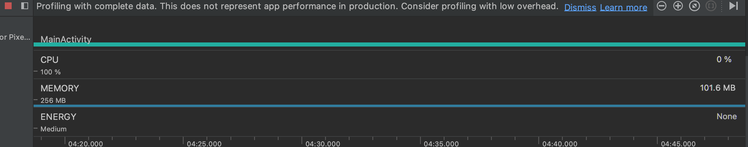

Figure 1. Analyzing app performance by using Android Profiler